what is JavaScript ?

javascript is a client side scripting language

javascript is a programming language

javascript is fast growing frontend scripting language

javascript is used most top 10 language wordwide

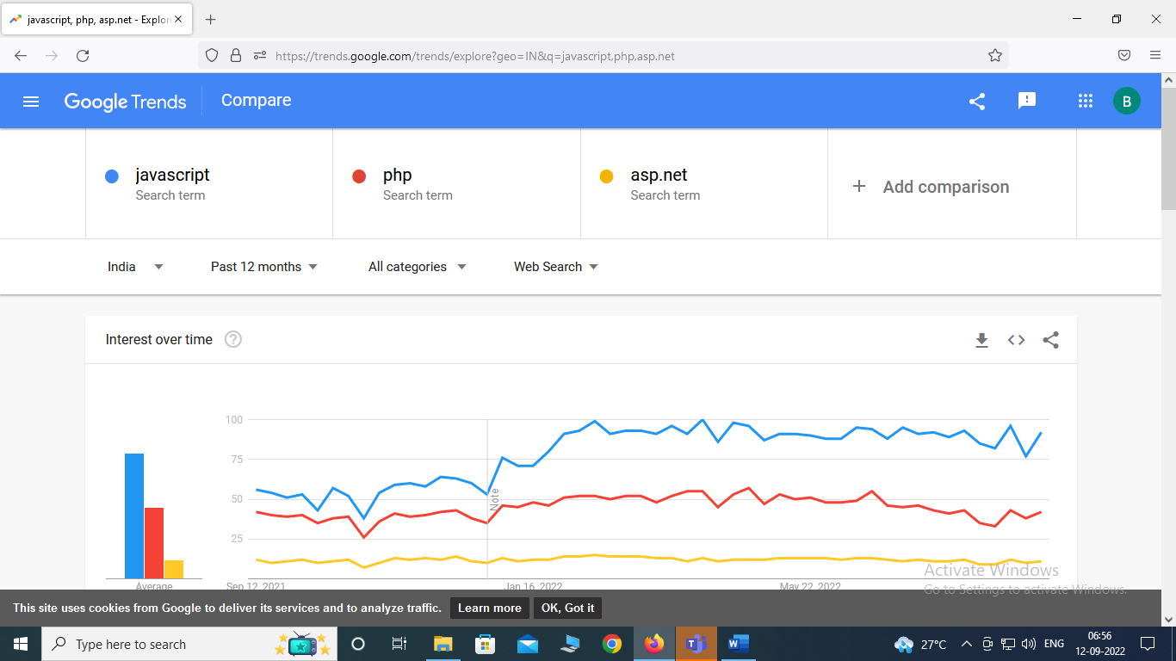

JavaScript is used to create calculator | form validation | browser cookie store | enable disable right click on browser etc.

JavaScript provides security on browser

JavaScript is used to load a loader in your website.

JavaScript is a case sensitive programming language

Eg: <script>

JavaScript is support on browser and load on browser.

JavaScript is used to defined a behaviour of your application

HTML =>structure

CSS=>style

JavaScript=>behaviour

JavaScript fast load data on web browser.

Javascript is called <head> and <body> both using <script> tag

How to call javascript in <head>

<head>

    <meta charset='utf-8'>

    <meta http-equiv='X-UA-Compatible' content='IE=edge'>

    <title>Page Title</title>

    <meta name='viewport' content='width=device-width, initial-scale=1'>

    <link rel='stylesheet' type='text/css' media='screen' href='main.css'>

    <script src='main.js'></script>

    <script type="text/javascript">

      alert('Are your sure to redirect on flipkart click for OK')

      window.location='https://www.flipkart.com';

    </script>

</head>

How to call javascript in <body>

<body>

    <script type="text/javascript">

        alert('Are your sure to redirect on flipkart click for OK')

        window.location='https://www.flipkart.com';

      </script>

</body>

Javascript external file extention is .js

Calling external js inside of html

load.js

alert('Hey i want to load flipkart please click OK')

window.location='https://www.flipkart.com';

load_flipkart.html

<!DOCTYPE html>

<html>

<head>

    <meta charset='utf-8'>

    <meta http-equiv='X-UA-Compatible' content='IE=edge'>

    <title>Page Title</title>

    <meta name='viewport' content='width=device-width, initial-scale=1'>

    <link rel='stylesheet' type='text/css' media='screen' href='main.css'>

    <script src="js/load.js"></script>

</head>

<body>

</body>

</html>

**JavaScript operator:**

JavaScript operator is used to operate or perform some actions there we used operator.

Eg: add a number , substract a number

**Type of operator :**

1. **Airthmatic operator :**

**eg: + , - , * , / , % etc**

1. **Assingment operator :**

**eg: =,==,=== etc**

1. **Comparision operator :**

**eg: >, < , >= , <= etc**

1. **logical operator :**

**eg: and &&, or || etc**

1. **ternary operator**

**eg: ?:**

1. **sorthand operator**

**eg: += , -=, *=, %= ,/= etc**

1. **concatenate operator**

**eg: + etc**

**JavaScript variable :**

**Variable**

A variable is used to just like a container where we stored a information about any data.

How to defined any variable :

var name=”brijesh”;

var a=1456;

var b=12.456;

let name=”rekha”;

let a=1455;

let b=12.5465;

const name=”Priya tank”;

const a=1456;

const b=12.4546;

**diff b/w var , let and const**

**var : to defined any variable i.e used to call inside of function or need to call outside of function or anywhere call or call globally there we take a var.**

eg: var a=102;

**let : to defined any variable i.e used to call inside of function only or call local.**

eg: let a=102;

**const :A const is defined to not change a data after store inside of const.**

eg: const a=102;

const name=”brijesh”;

const b=10.45465;

**Data type: A datatype is a value which one is stored inside of variable.**

**let a=10; integer or number**

**let name=’brijesh’; string or character**

**let name=”vidhi”; string**

**let b=10.5468; float**

**let c=true; Boolean**

**let d=false; Boolean**

**let e={name:”brijesh”,age:32,education:”M.tech(IT)”}**

**//object**

**let f=544121212312412121212121214; number or integer**

**let g=54252425554n; //bigInteger**

**typeof() : type Is a javascript method i.e used to check a variable datatypes.**

**eg: let e={name:”brijesh”,age:32,education:”M.tech(IT)”}**

**document.write(typeof(e));**